**Name:** Norberth Erlin Putra

**NIM:** 2602062564

**Major:** Computer Science – Global Class

**Website:**

**Navbar & Footer:**

These elements are present in every page.



The navbar is used to navigate through all the different pages, when the cursor is hovered on the text, it will change color, and when you are in said page, the text will stay a light blue color.

The footer has 4 icons that are all clickable, that being the discord, twitter, youtube channel, and Instagram of the developers (in this case, I linked everything to the social media of sea of stars).

**Homepage:**

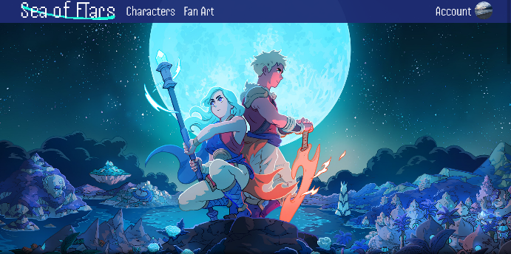The homepage consists of a splash screen, the game trailer, information about the game, and a button to get the game in steam.

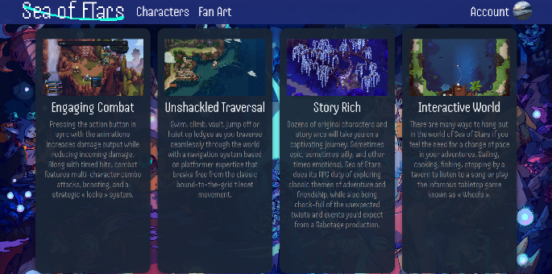

The video is an iframe, so it can be played when the user has an internet connection, and the steam button will lead the user to the steam page of the game (in this case, the steam page of sea of stars)

**Character Page:**

The Character Page is divided in two, the “Heroes” section and the “Enemies” section. Each character that has an icon is clickable and will lead the user to the character details of that specific character with its gif, picture, name, an description.

**Fan Art Page:**

The Fan Art Page consists of the splash screen with a clickable “Discord” text which will lead the user to the discord (sea of stars). The rest of the page consists of fan art submissions with clickable images (to view full res) and if there are sources, the name of the creator will be underlined, and it will lead the users to the source of the fan art.

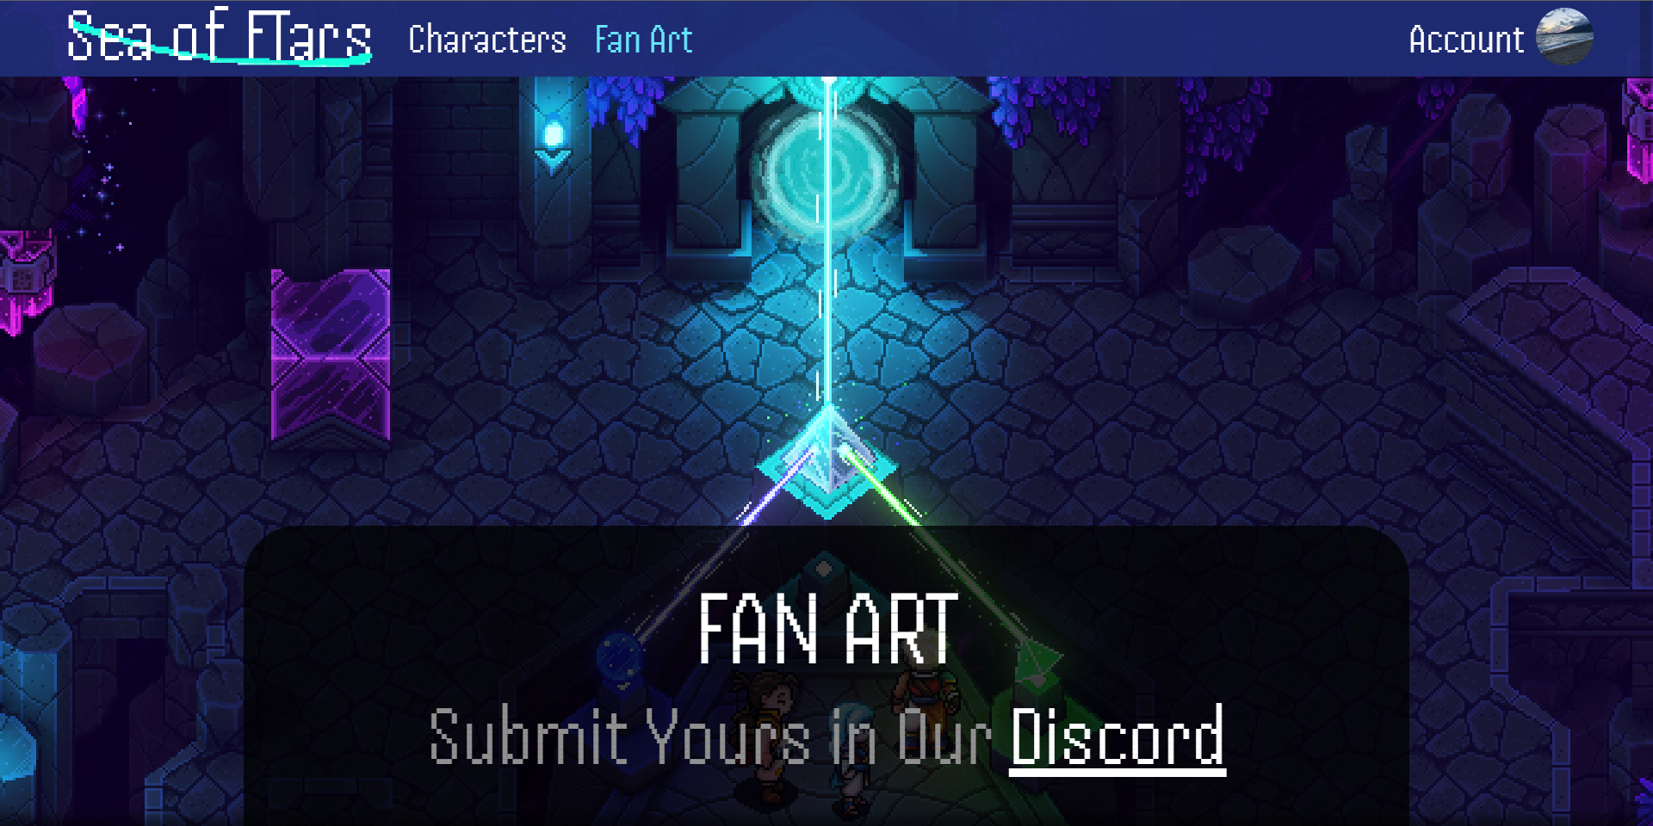

**Account Page:**

The account page consists of the register and the login page. Cycling through both of these requires the user to click the “Already have an account?” and “Don’t have an account?” texts respectively. The “Forgot Password/Username” and “Terms of Service” texts are non-functional. The login page is non-functional, and the sign in button will just lead the user to the home page. The registration page has a username, country, email, password, and a confirm password form along with a checkbox to agree on the terms of service. This page has validations, namely username has to be 3-20 characters long, the user has to choose a country, the email has to have an @ and ends with .com, the password has to be at least 8 characters long, has both lowercase and uppercase letters, the password must be the same with the confirmation, and the user has to agree with the terms of service. If the user fails to do either of them, they will be informed through an error message at the end of the form, just above the sign-up button. If all the conditions are met, the user will be alerted that the registration was successful and will be directed to the home page.

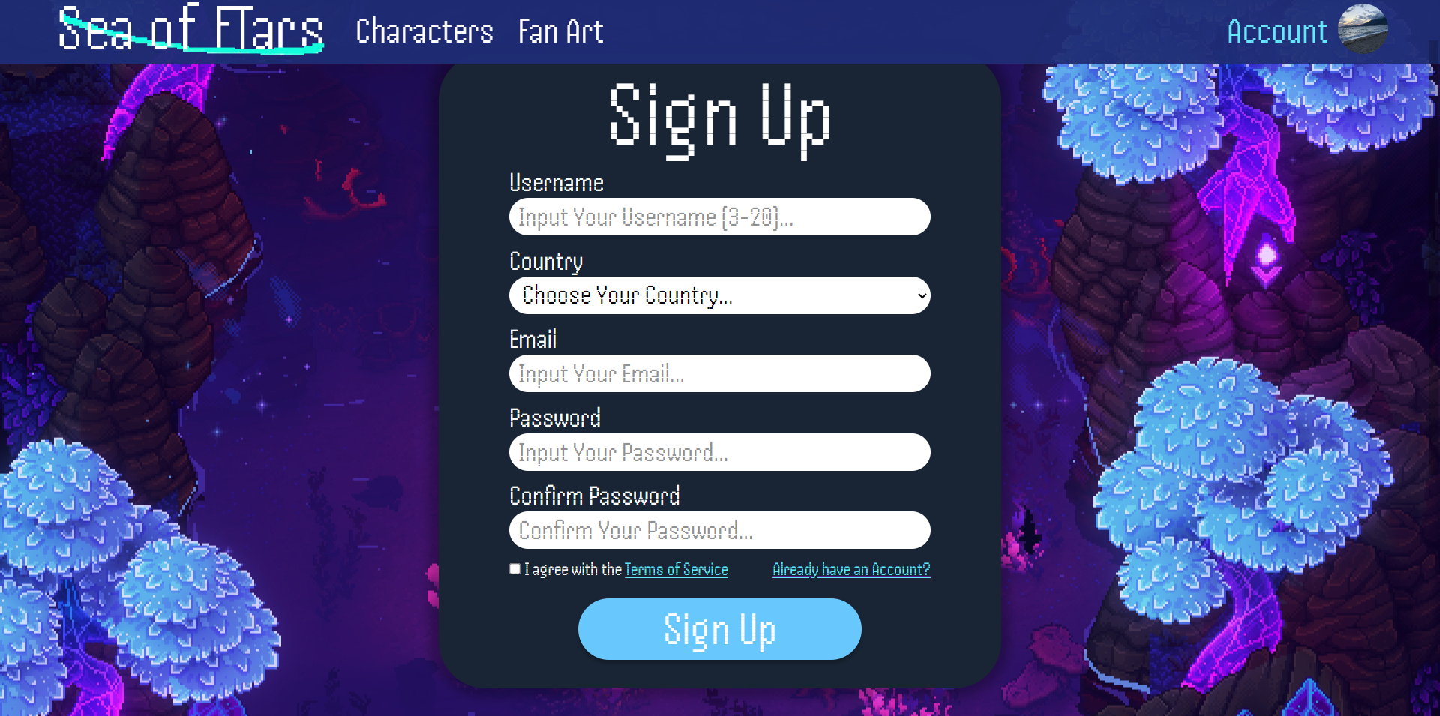

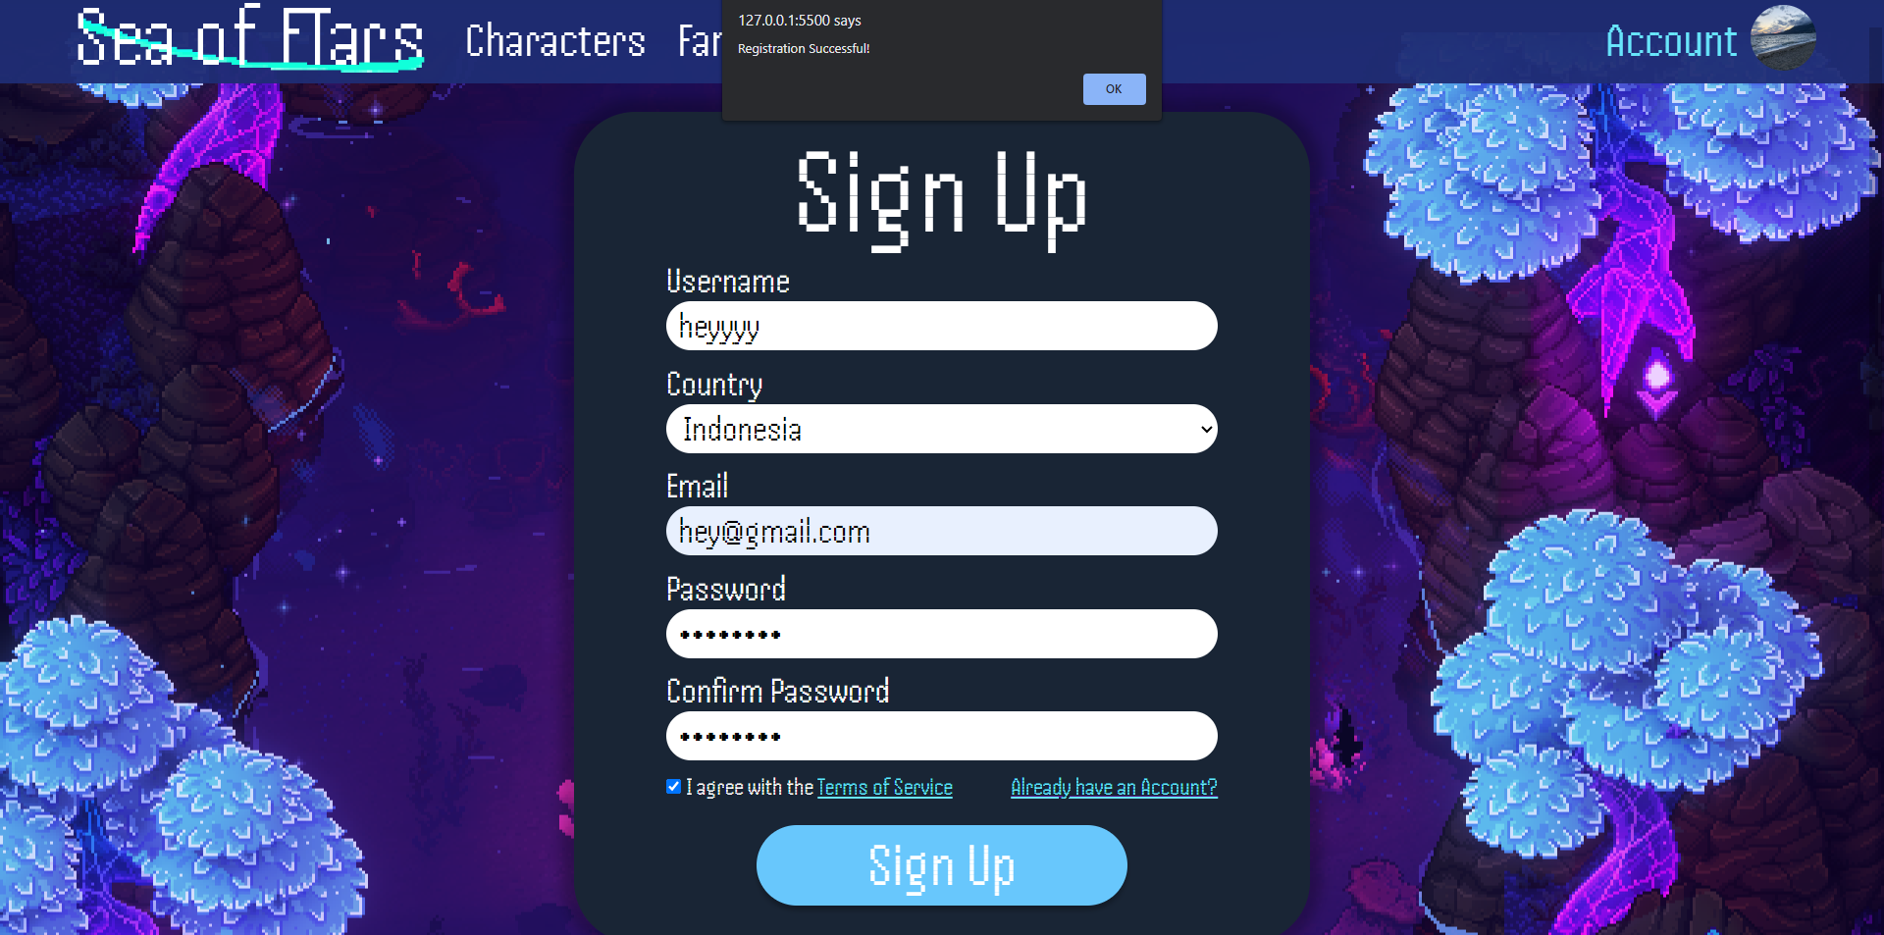

**Icons:**

Each page uses the same icon, except for the character detail pages.





**Sources:**

**Main Source (Original website):**

<https://seaofstarsgame.co/>

<https://seaofstarsgame.co/fan-art/>

<https://sabotagestudio.com/presskits/sea-of-stars/>

https://compendium.seaofstarsgame.co/

**Character Sprites:**

<https://seaofstars.fandom.com/wiki/Zale>

<https://seaofstars.fandom.com/wiki/Valere>

<https://seaofstars.fandom.com/wiki/Garl>

<https://seaofstars.fandom.com/wiki/Ant_Bruiser>

<https://seaofstars.fandom.com/wiki/Arcane_Sentry>

<https://seaofstars.fandom.com/wiki/Gulgul>

https://seaofstars.fandom.com/wiki/Spellbook

**Company Logos (social media and steam):**

<https://www.pngmart.com/image/353348>

<https://discord.com/branding>

<https://www.iconsdb.com/white-icons/twitter-icon.html>

<https://clipart-library.com/clipart/dc4LABqni.htm>

<https://www.edigitalagency.com.au/instagram/new-instagram-logo-white-png-transparent/>

**Information:**

<https://www.w3schools.com/>

**Custom Sprites (Made with):**

<https://www.piskelapp.com/>

**Font (Handjet):**

<https://fontesk.com/handjet-font/>

**Figma Link:**

<https://www.figma.com/file/d60iBREh5wAZn2LbOQIKa4/Sea-Of-FTars?type=design&node-id=0%3A1&t=ghmEkx9PitdkwA9a-1>

**Figma Prototype:**

<https://www.figma.com/proto/d60iBREh5wAZn2LbOQIKa4/Sea-Of-FTars?type=design&node-id=0-1&scaling=min-zoom&page-id=0%3A1&starting-point-node-id=1%3A2>

